Health Analysis Project

R Programming Language

Amber Grace Hulsey
April 28, 2026
Introduction
This report will use many different factors to try and predict sleep duration using a dataset from Kaggle. The data was collected by running a synthetic model on 300 different people as if they are wearing a fitness tracker device. Because it is a synthetic model, there is no concern for privacy issues. It was measured for six months every day and recorded many different health measurements. In this report, we will focus on sleep duration, stress score, steps, and average heart rate. This project is relevant in today's world because health and fitness is a huge part of one’s lifespan. According to Healthy Longevity, “What you do today can transform your health span or how you age in the future” (Healthy Longevity • The Nutrition Source, 2022). It is important to be aware of one’s health history and measurements to help improve mental and physical health. My research question is how stress levels, physical activity, and heart rate help predict one’s sleep duration.
Data
I began by cleaning the data and removing the observations that included “NA” for the variables. Also, I removed all the observations with a value of 0 for the average heart rate. Both of these cleaning techniques will improve the model's results by removing inconsistencies. There is a total of 54,139 observations in this dataset after cleaning it. The dependent variable is Sleep Duration, which is measured in hours per night. Descriptive statistics are shown in the table below. All of the variables, dependent and independent, are numerical values, so no dummy variables had to be created. My independent variables are Stress Score, Steps, and Average Heart Rate. Stress levels are represented by a score of 0-100 and has a mean value of 67.04. It would be reasonable to expect this relationship to be negative because the more stressed someone is, the less likely they are to sleep for longer periods of time.
Physical activity is shown in this project through the number of steps each individual takes in a day. This is used as a proxy to represent one’s physical health and cardio. We would expect this relationship to be positive; the more active someone is, the more sleep they are receiving. The average steps in a day from all 300 individuals is 9278.28. Heart rate is measured as the average beats per minute for that day for that individual per observation. The average heart rate of all observations is 87.10. We would expect these three independent variables to be statistically significant because they play a role in one’s ability to receive a good night's sleep. These are the kind of factors that doctors and health professionals study and analyze when individuals come in about having insomnia or other sleep issues.
Descriptive Statistics Table
Variable: | Mean | Std. Dev. | Min | Max
Sleep Duration | 6.99 | 0.84 | 3.5 | 10.5
Stress Score | 67.05 | 11.75 | 19 | 100
Steps | 9,278.21 | 4,012.75 | 200 | 29,651
Heart Rate | 87.10 | 10.35 | 55 | 127.27

Method
Because I must take into account the repeated measures within each person, the method I will use is a linear mixed effects model. This kind of model helps with the issue of having nonindependence in the data. Since the 300 individuals are being measured repeatedly over six months, we cannot run a normal regression without accounting for this correlation because each individual is its own group. Having these groups creates the need for combining mixed effects and fixed effects (Introduction to Linear Mixed Models, 2026). Also, I had to scale the independent variables. R Programming Language suggested this since each variable is on an extremely different scale and needed more numerical stability. For example, the maximum stress score is a 100 while the maximum steps are 29,651. On top of this, the standard deviation of the stress score is 11.75 while steps’ is 4012.75.
Restricted Maximum Likelihood (REML) is used in R to estimate the variance while accounting for both the random and fixed effects (Bates et al., 2015). Again, this takes into consideration the repeated measurements within each individual and helps with the issue of nonindependence. R Programming Language assumes each observation is independent of one another; however, this is not the case for this dataset that has multiple observations for one individual. REML helps us see the results in a more efficient and accurate way by telling R to group the related data, or persons, together.
Results and Interpretation
Linear Mixed Effects Model Results
Variable: | Estimate | Std. Error | t Value | Pr(> | t |)
(Intercept) | 6.990 | 0.01565 | 446.603 | <2e-16
Stress Score | -0.6623 | 0.00328 | -202.234 | <2e-16
Steps | 0.00197 | 0.00418 | 0.471 | 0.638
Heart Rate | 0.00297 | 0.00382 | 0.777 | 0.437

After running the linear mixed effects model, it concluded that on a 95% confidence interval, one’s stress level is the only independent variable that helps predict sleep duration after accounting for steps and heart rate. The negative estimate value tells us that there is a negative relationship between stress and sleep duration. As someone’s stress score increases by one unit, on average, sleep duration will decrease by 0.6623 hours. The intercept tells us that the average person gets 6.99 hours of sleep when all factors are held constant. The Steps and Average Heart Rate variables are not statistically significant at the 0.05 level when looking at the p-value and t-value.
Correlation of Fixed Effects Table
Variable: | Stress Score | Steps
Stress Score | 0 | 0
Steps | 0.233 | 0
Heart Rate | -0.012 | 0

According to the correlation table, there is not a multicollinearity issue because the correlation between each independent variable is either zero or very close to it. This begs the question of why steps and heart rate are not statistically significant. Realistically, this is potentially due to these variables not having a strong effect on sleep duration on a within-person basis. Even though this may be the case for this model, it would still be reasonable to suspect that there is a relationship between one’s physical activity, heart rate, and sleep duration. A limitation may be that steps were not an accurate depiction of one’s physical activity. There could potentially have been a better proxy to use. On top of this, the specific heart rate chosen may not have been the best indicator. I chose to use average heart rate for that given day; however, the resting heart rate may have been a much better predictor for this model and, therefore, may have changed the results.
Stress Score and Sleep Duration Box Plot
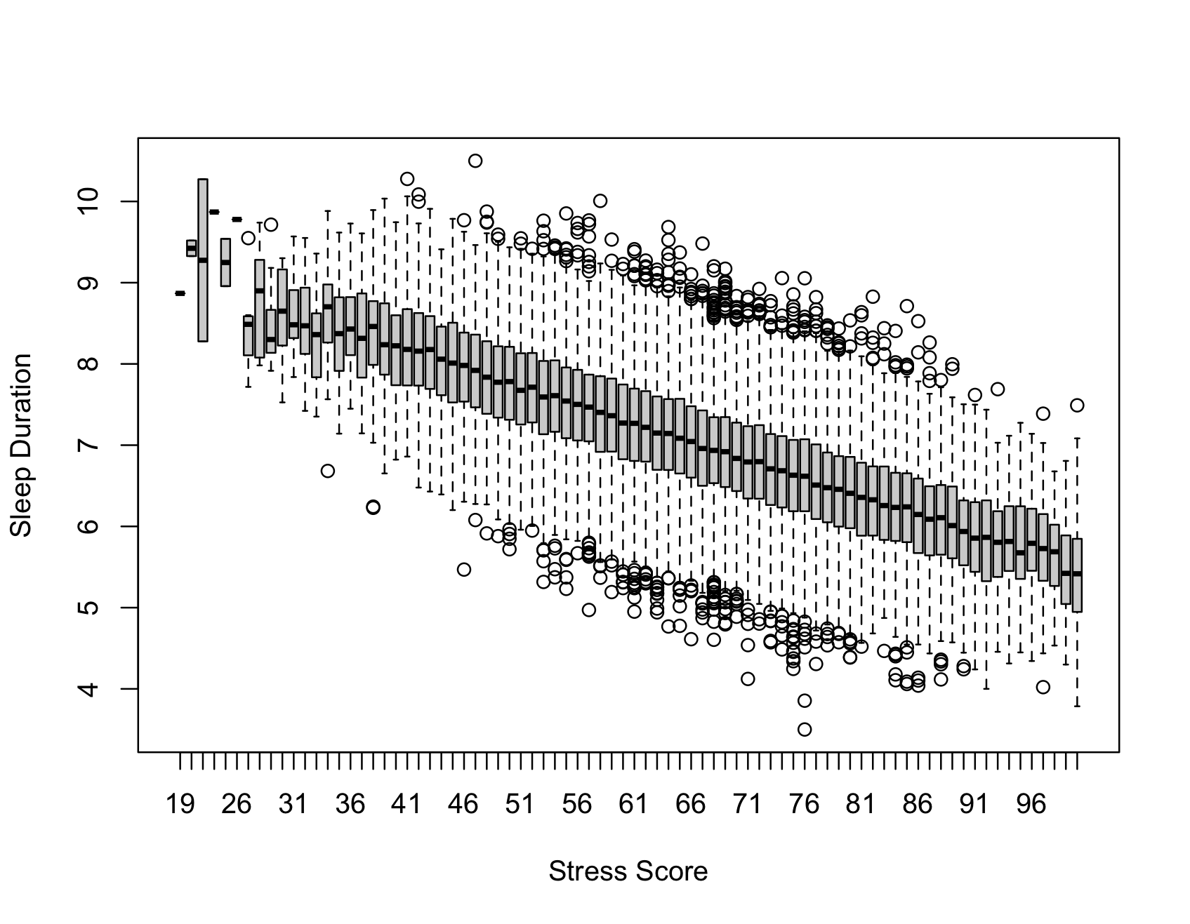
The plot above shows the results found in the mixed effects model in a visual way. As shown above, the relationship is negative. While stress increases, the sleep duration decreases. This pattern is consistent across all observations, and the mean, lower bound, and upper bound all follow this pattern. According to Dr. Anise Wilson from Baylor College of Medicine, “High levels of stress impair sleep by prolonging how long it takes to fall asleep and fragmenting sleep,” which accurately aligns with our results in the model and in the plot (How Stress Can Affect Your Sleep, 2019).

Histogram of Stress Score
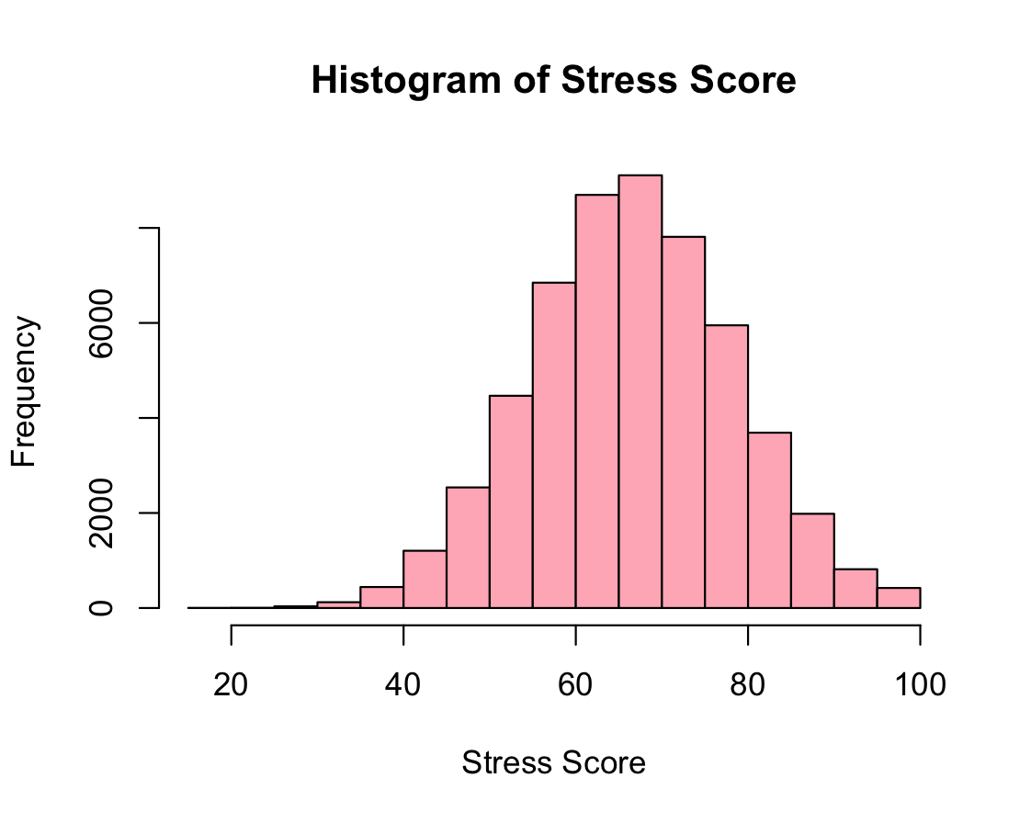
The graph above shows the frequency of the stress score results in a histogram. It is a normal distribution and most of the data falls between 60 and 80, which shows that in this data, most people are showing relatively high stress levels. After seeing that there were individuals whose stress score was at the maximum of 100, I went to look for the common denominators between them. Of the observations that had a 100 stress score for that day, their mood was “very bad” and they were only receiving between 3 and 5 hours of sleep that night. This helps prove the case that stress plays a vital role in one’s sleep and ultimately their overall wellbeing. On the other hand, I also went to analyze those who had a stress core of below 40 for that day. Their mood was either “good” or “very good” and their sleep duration was mostly always above eight hours. When someone is less worried, their sleep improves because they are not in fight or flight mode.
Histograms of Steps and Heart Rate
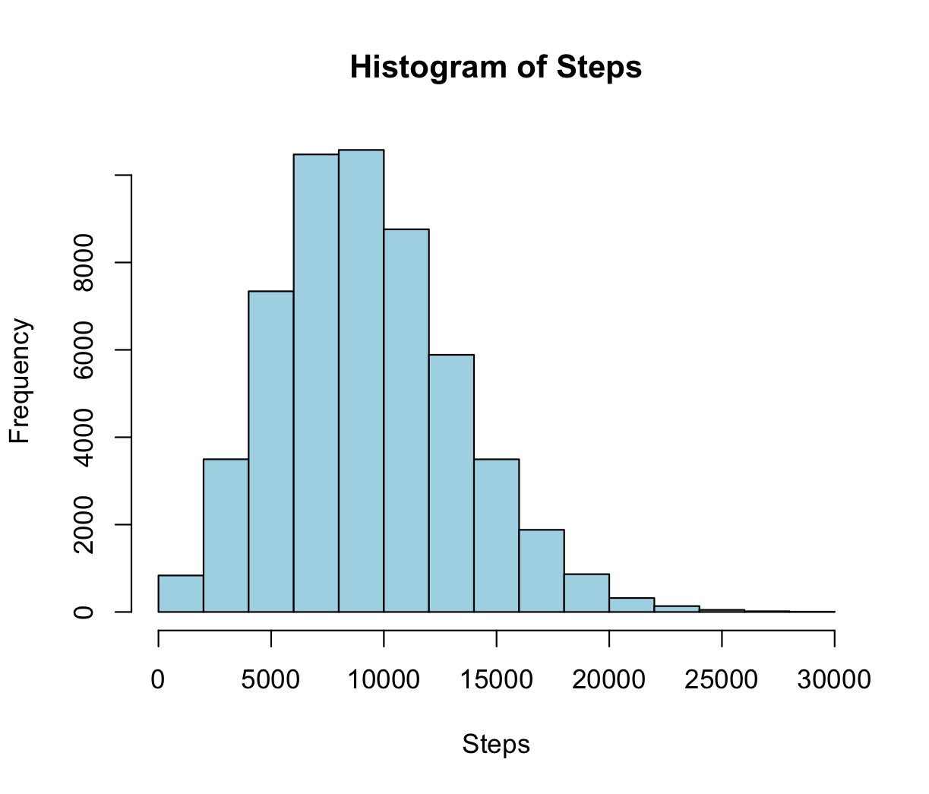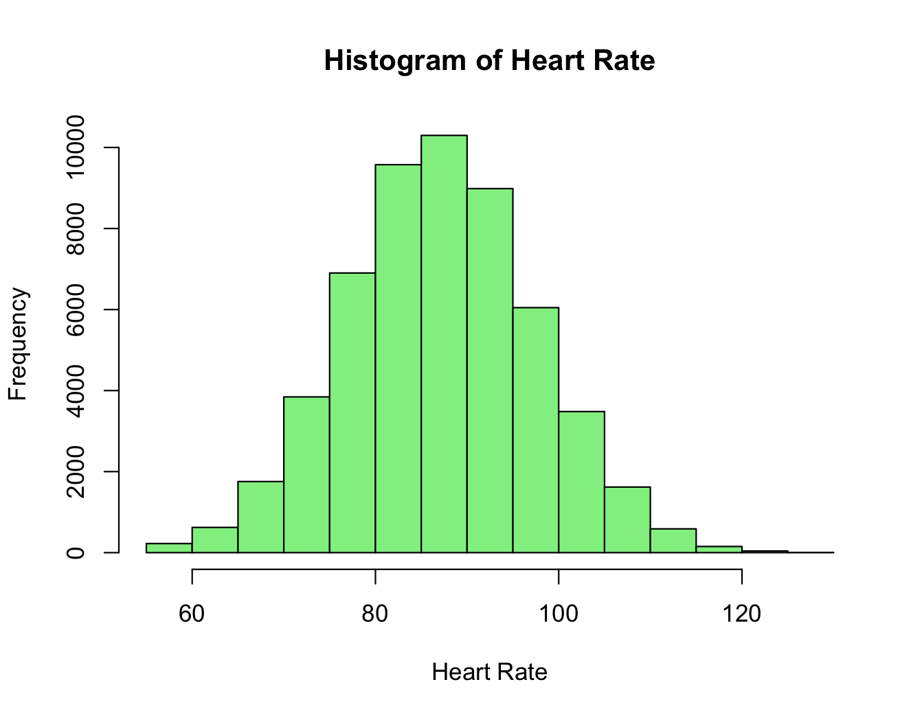
This histogram on the left shows the frequency of the steps variable. Similar to the stress score graph, this is also showing a normal distribution. Most of the values lie in the 7,000 to 11,000 range. It is interesting to note that there is at least one observation that hits the 25,000 mark, which is over double what the average steps in a day is. This is possibly skewing the data and could arguably be an outlier. When deep diving into the dataset, observations with both higher and lower steps in a day gained about the same number of hours of sleep that night. Making this realization helps us better understand why the model showed this variable to be not statistically significant.
The plot on the right shows the frequency of one’s heart rate in this dataset. Most of the data is between 80 bpm and 100 bpm, which is an average range. It actually makes sense why this variable turned out to be not statistically significant after looking at the data more. Observations with a higher heart rate still received, on average, over seven hours of sleep. Also, observations with a lower heart rate slept over seven hours as well. This shows that average heart rate does not substantially affect sleep duration in this model. Once again, it is normally distributed. This is something intriguing to point out because all of the independent variables are normally distributed. These graphs are important to look at because the data is not collected on real people, and we should ensure the numbers make sense. This may be seen as unrealistic because this data is synthetic and no one’s actual personal information was assembled. However, there are benefits to having this kind of model because of the protection of data privacy.
Conclusion
Even though this model makes the conclusion that steps and heart rate are not statistically significant, I would argue that it does still have a role in one’s sleep. Having a healthy heart impacts all other aspects of life, including someone’s sleep ability. As mentioned earlier, it is possible a better variable to include would have been the resting heart rate because of the dependent variable being sleep duration. Also, how active someone is will also have a part in someone’s length of sleep. If a different proxy for physical health were included, the results could possibly have been statistically significant. One limitation of this model is the fact that it is a synthetic model, which means the data is generated. It is as close to realistic as possible, but not entirely. One suggestion for this analysis would be to collect real data and compare the results to this one and see where it aligns and differs.
It is no surprise that stress has the most impact on one’s sleep duration in this model. Stress affects everyone differently; however, most of the time sleep is involved one way or another. It is also no surprise that the relationship is negative. As one’s stress levels rise, the less sleep they typically get. For example, a college student stressed about finals will sleep less to study. On the other hand, the same college student during their summer break will typically sleep more without the worries of school. This project could help many different kinds of people including doctors, therapists, students, parents, and more. Becoming more aware of yours and others stress levels will help determine the practices necessary to improve sleep.

References
‌Bates, D., Mächler, M., Bolker, B., & Walker, S. (2015). Fitting linear mixed-effects models using lme4. Journal of Statistical Software, 67(1), 1–48. https://doi.org/10.18637/jss.v067.i01
Healthy Longevity • The Nutrition Source. (2022, November 18). The Nutrition Source - Harvard Chan School. https://nutritionsource.hsph.harvard.edu/healthy-longevity/
How stress can affect your sleep. (2019). Baylor College of Medicine. https://www.bcm.edu/news/how-stress-can-affect-your-sleep
‌Introduction to Linear Mixed Models. (2026). Ucla.Edu. https://stats.oarc.ucla.edu/other/mult-pkg/introduction-to-linear-mixed-models/
‌meftun akarsu. (2025). Health + Wearables + Stress/Sleep Tracking (syntc). Kaggle.Com. https://www.kaggle.com/datasets/mftnakrsu/health-wearables-stresssleep-tracking-syntc?resource=download

